**Main Page Section 1 Assignment 2**

**Objectives**

* Understand the kinds of jobs available within the sports and music industry for those doing data analytics.
* Understand the soft skills required
* Understand the hard skills (technical skills required)

**Main Learning Goal**

Students will understand the kinds of jobs available within the sports and music industries and see how their hard and soft skills line up against the job posting.

**Focus Question**

What does it take to get a position for data analytics in the sports or music industry?

**Elicit**

Congrats! You are out looking for a job in the sports or music industry to follow your passion. You have a bachelor's degree from a university in Florida, in some STEM area. You have taken multiple courses in data analytics as that has interested you.

Look at the two job postings below from Linkedin.

**

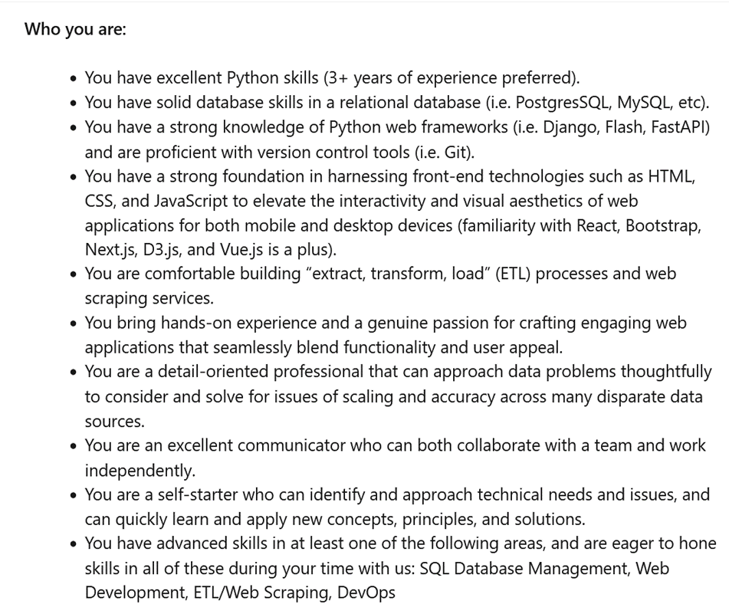

**Sports Industry**

****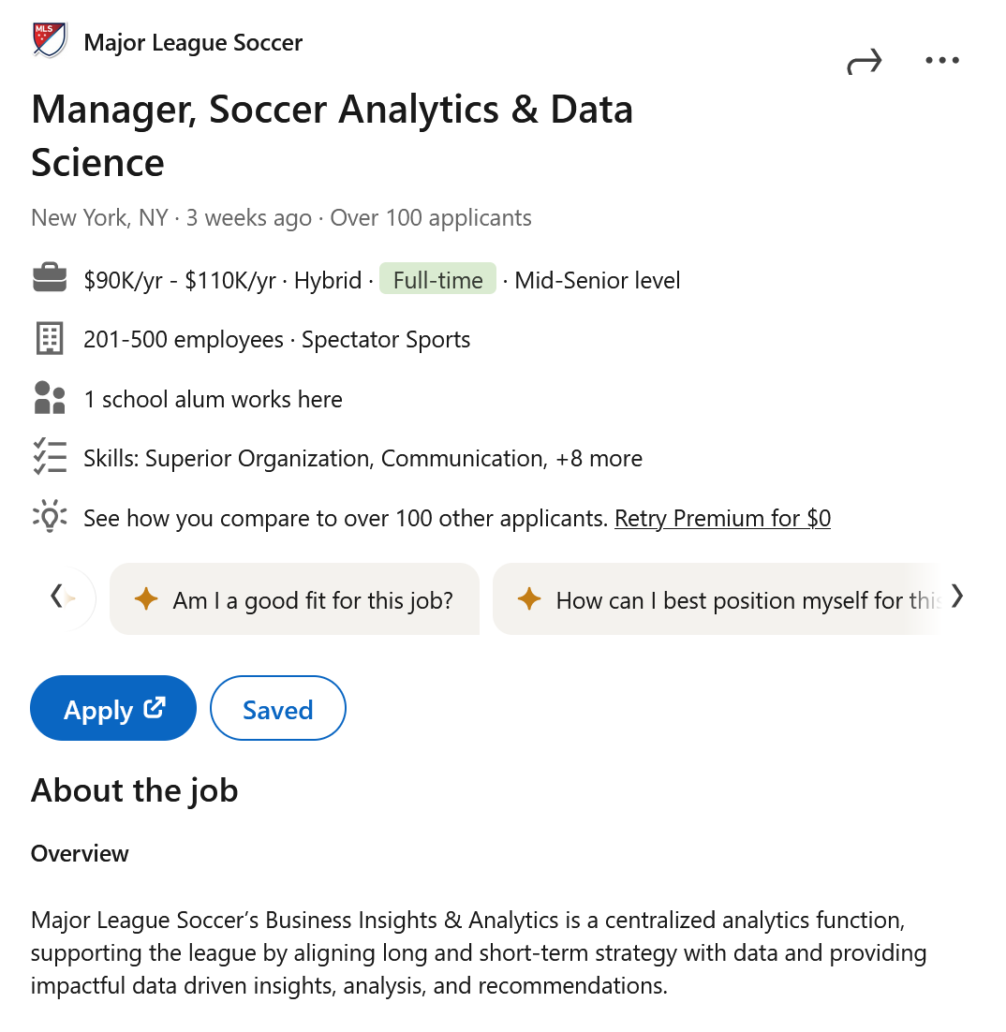

**TO DO:**

**1. Fill out the first part of the worksheet for the job postings.**

**Refine/Reflect**

When ever we look at job postings, we should view them as an opportunity to assess our skills and see what new things we can learn.  The highest paying jobs require some level of technical skills and we want to think about how we can develop these skills early in our career and school settings.

TO DO:

2. Go back to the worksheet above and fill out the second part where you assess your skills related to the job postings.

3. Share your skills with a partner and the class. Collectively what skills do you all have, what skills do you all need to develop?